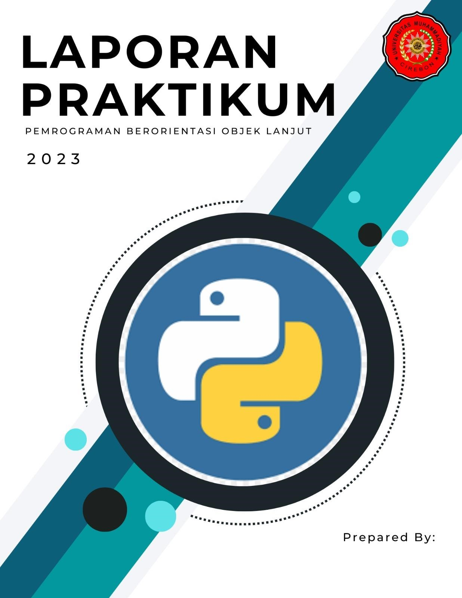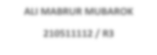

**ALI MABRUR MUBAROK**

**210511112**

**/ R**

**3**

Tugas-3 PBO 2023

Nama : Mohamad Maulana

Nim : 210511121

Kelas : TI21C / R3

Aplikasi Pemutar Suara 10 Hewan yang berbeda – beda (format: *.mp3)

Script =

#nama : ARYA SUBHANDHI

#nim : 210511107

#kelas : TI21C / R3

from tkinter import * from turtle import color from playsound import playsound

root3 = Tk() root3.title('Aplikasi Macam - macam suara hewan') root3.config(background="blue")

Label(root3, text="PEMUTAR SUARA JENIS - JENIS HEWAN", bg="yellow", font="Lobster 30").grid( row=0, column=0, columnspan=3, pady=5)

class Animal: def make_sound(self):

print("The animal makes a sound")

class Dog(Animal): def make_sound():

playsound('D:\TUGAS FILE MANAGER (SISTEM INFORMASI)\ALI MABRUR MUBAROK\SEMESTER

4\PEMROGRAMAN BERORIENTASI OBJEK LANJUT\Pertemuan 3\Hewan\suara - anjing.mp3')

b1 = Button(root3, text="Anjing", font="Normal 20", command=make_sound, relief=RAISED, bd=5, bg="lightgray", activebackground="purple") b1.grid(row=3, column=0, padx=15, pady=15)

class Cat(Animal): def make_sound():

playsound('D:\TUGAS FILE MANAGER (SISTEM INFORMASI)\ALI MABRUR MUBAROK\SEMESTER 4\PEMROGRAMAN BERORIENTASI OBJEK LANJUT\Pertemuan 3\Hewan\suara - kucing.mp3')

b2 = Button(root3, text="Kucing", font="Normal 20", command=make_sound, relief=RAISED, bd=5, bg="lightgray", activebackground="purple") b2.grid(row=3, column=1, padx=15, pady=15)

class Chicken(Animal): def make_sound():

playsound('D:\TUGAS FILE MANAGER (SISTEM INFORMASI)\ALI MABRUR MUBAROK\SEMESTER 4\PEMROGRAMAN BERORIENTASI OBJEK LANJUT\Pertemuan 3\Hewan\suara - ayam.mp3')

b3 = Button(root3, text="Ayam", font="Normal 20", command=make_sound, relief=RAISED, bd=5, bg="lightgray", activebackground="purple") b3.grid(row=3, column=2, padx=15, pady=15)

class Pig(Animal): def make_sound():

playsound('D:\TUGAS FILE MANAGER (SISTEM INFORMASI)\ALI MABRUR MUBAROK\SEMESTER 4\PEMROGRAMAN BERORIENTASI OBJEK LANJUT\Pertemuan 3\Hewan\suara - babi.mp3')

b4 = Button(root3, text="Babi", font="Normal 20", command=make_sound, relief=RAISED, bd=5, bg="lightgray", activebackground="purple") b4.grid(row=4, column=0, padx=15, pady=15)

class Bird(Animal): def make_sound():

playsound('D:\TUGAS FILE MANAGER (SISTEM INFORMASI)\ALI MABRUR MUBAROK\SEMESTER 4\PEMROGRAMAN BERORIENTASI OBJEK LANJUT\Pertemuan 3\Hewan\suara - burung.mp3')

b5 = Button(root3, text="Burung", font="Normal 20", command=make_sound, relief=RAISED, bd=5, bg="lightgray", activebackground="purple") b5.grid(row=4, column=1, padx=15, pady=15)

class Elephant(Animal): def make_sound():

playsound('D:\TUGAS FILE MANAGER (SISTEM INFORMASI)\ALI MABRUR MUBAROK\SEMESTER 4\PEMROGRAMAN BERORIENTASI OBJEK LANJUT\Pertemuan 3\Hewan\suara - gajah.mp3')

b6 = Button(root3, text="Gajah", font="Normal 20", command=make_sound, relief=RAISED, bd=5, bg="lightgray", activebackground="purple") b6.grid(row=4, column=2, padx=15, pady=15)

class Sheep(Animal): def make_sound():

playsound('D:\TUGAS FILE MANAGER (SISTEM INFORMASI)\ALI MABRUR MUBAROK\SEMESTER 4\PEMROGRAMAN BERORIENTASI OBJEK LANJUT\Pertemuan 3\Hewan\suara - kambing.mp3')

b7 = Button(root3, text="Kambing", font="Normal 20", command=make_sound, relief=RAISED, bd=5, bg="lightgray", activebackground="purple") b7.grid(row=5, column=0, padx=15, pady=15)

class Monkey(Animal): def make_sound(): playsound('D:\TUGAS FILE MANAGER (SISTEM INFORMASI)\ALI MABRUR MUBAROK\SEMESTER 4\PEMROGRAMAN BERORIENTASI OBJEK LANJUT\Pertemuan 3\Hewan\suara - monyet.mp3')

b8 = Button(root3, text="Monyet", font="Normal 20", command=make_sound, relief=RAISED, bd=5, bg="lightgray", activebackground="purple") b8.grid(row=5, column=1, padx=15, pady=15)

class Cow(Animal): def make_sound():

playsound('D:\TUGAS FILE MANAGER (SISTEM INFORMASI)\ALI MABRUR MUBAROK\SEMESTER 4\PEMROGRAMAN BERORIENTASI OBJEK LANJUT\Pertemuan 3\Hewan\suara - sapi.mp3')

b9 = Button(root3, text="Sapi", font="Normal 20", command=make_sound, relief=RAISED, bd=5, bg="lightgray", activebackground="purple") b9.grid(row=5, column=2, padx=15, pady=15)

class Lion(Animal): def make_sound():

playsound('D:\TUGAS FILE MANAGER (SISTEM INFORMASI)\ALI MABRUR MUBAROK\SEMESTER 4\PEMROGRAMAN BERORIENTASI OBJEK LANJUT\Pertemuan 3\Hewan\suara - singa.mp3')

b10 = Button(root3, text="Singa", font="Normal 20", command=make_sound, relief=RAISED, bd=5, bg="lightgray", activebackground="purple") b10.grid(row=6, column=1, padx=15, pady=15)

def animal_sound(animal): animal.make_sound()

root3.mainloop()

